HAZEL DELL SPORTS MED & REHAB CLINIC DBA FORGEY SPORTS MED & REHAB CLINIC
300 Grand Blvd., Ste. # B200, Vancouver, WA 98661 P: 360-573-5500 F: 360-573-9075
RATE YOUR FUNCTION: Place an X on the line below representing your current level of function.

COMPLETE FUNCTION------------------------------------------------------------------------------------------------NO FUNCTION

Job Title: _____________________________________ Are you currently working? Yes____ No____

Check all appropriate: Full time_____ Full Duty_____ Part time_____ Light Duty_____

Work Schedule:____________________________________________________________________________

Describe your job duties:_____________________________________________________________________

Maximum lifting up to _______lbs Occasional lifting up to ________lbs

If newly employed, list employers name, job title, and duties:________________________________________

RATE YOUR PAIN: Place an X on the line below representing your current level of pain.

PAIN FREE----------------------------------------------------------------------------------------------------WORST PAIN POSSIBLE

Mark the areas on your body where you feel your pain. Include all affected areas. If your pain radiates, draw an arrow from where it starts to where it stops. Please extend the arrow as far as the pain travels. Use the appropriate symbol(s) listed below.
Age______
Ht. ______
Wt.______
DOI______
Mark the appropriate selection below:

The pain is worse:
( ) first wake
( ) morning
( ) mid day
( ) afternoon
( ) evening
( ) bedtime

The pain is least:
( ) first wake
( ) morning
( ) mid day
( ) afternoon
( ) evening
( ) bedtime

Ache: >>>
Numbness: ===
Pins/Needles: OOO
Burning: XXX
Stabbing: ///
Throbbing: ***
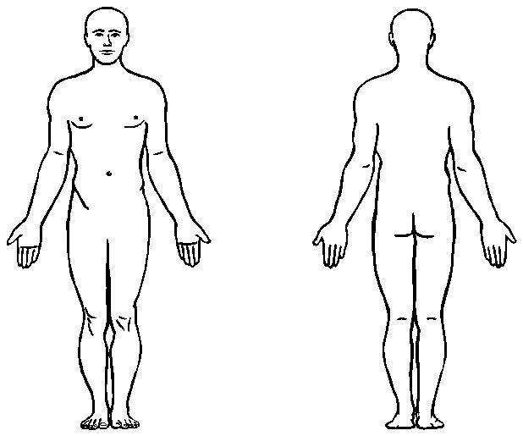

Frequency of pain: ( ) Intermediate 25% ( ) Occasional 25-50% ( ) Frequent 50-75% ( ) Constant 75-100%
Average time of day in pain: ( ) 1 hr ( ) 1-4 hrs ( ) 4-8 hrs ( ) when not lying down ( ) 24hrs
What activities make the pain better:____________________________________________________________________
What activities make the pain worse:____________________________________________________________________
RATE YOUR ACTIVITY FUNCTION: Place an X on the line below representing your current level of function.
COMPLETE FUNCTION---------------------------------------------------------------------------------------------------------------NO FUNCTION
Patient Name (Print):______________________________________________
Patient Signature:_________________________________________________ Date:___________________________

